Contents Page

Given Briefs 2

Initial Game / App Idea 2

Final / Chosen Idea 2

Adding Gamification 2

Research towards App Avatars 2

Designing the Avatar 4

Avatar Base 4

Avatar Features 4

Eyes 4

Mouth & Hair 5

Arms & Hands: 5

Customisation Assets: 6

Sunglasses: 6

Cap / Snapback: 6

Challenges & What I’ve learned: 7

Modelling Software: 7

Organic Modelling: 7

Conclusion: 7

References 8

# Given Briefs

At the beginning of the project my group received our selection of project briefs, which included; interaction within games, services for museums, augmented reality based and healthcare related.

After a couple a group meetings where all options were discussed, we elected to use a simple voting system to ensure everyone had an equal say, resulting in the selection of a mobile gaming app to transform healthcare.

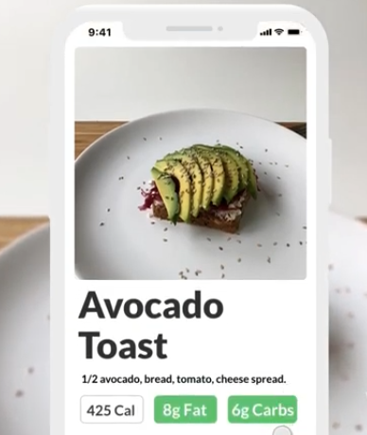We then looked at both the given briefs and their requirements to see how we could merge them together to create a healthcare application.

Figure

## Initial Game / App Idea

Once our transforming healthcare, mobile application brief was approved, we set about brainstorming potential ideas which would be compatible to support the brief.

We initially came up with some ideas relating to food nutrition and weight loss programs but they have all been done before, so in order to stretch ourselves technically and stand out, our group decided to incorporate augmented reality into the app. An example is shown in figure 1 (UX Agency, S 2018)

## Final / Chosen Idea

After a couple of weeks of research into current competitors and how to stand out using augmented reality, we chose to design an app to support people with both forms of diabetes.

This app will help people track how much insulin they’ll need during the day, why they need it, the calorie and nutrition in the product which in the long term could help reduce their usage by improving their diet.

Our method is to allow people to scan their food and drink products by taking a photo of the item, at which point the app will show them its nutritional value, ingredients, and a rating out of five towards their current nutritional needs, whilst also retaining a photo of the product.

## Adding Gamification

Whilst the group leader and UX designers conducted further research into augmented reality and how it could be included in the app, our game animator and I conducted research into including gamification to help attract more users. We looked at how other similar apps had tried to add this feature as well as software options such as Microsoft.

## Research towards App Avatars

Based on our initial research we discovered that players do not like having a character on their screen which has no purpose, such as the paperclip from Microsoft Word. So we chose to create an online questioner using Survey Monkey to get some results from the general public on what they would like to see in a nutrition app (Compsoft 2020).

The results of which are show in figures 2- 6

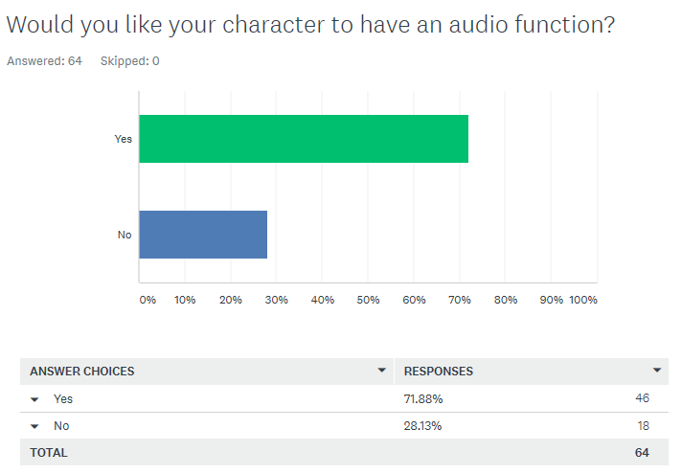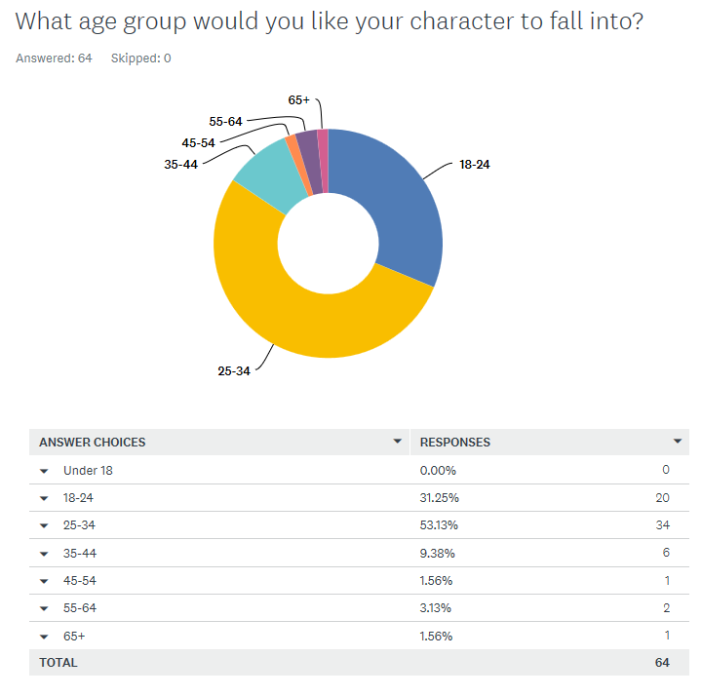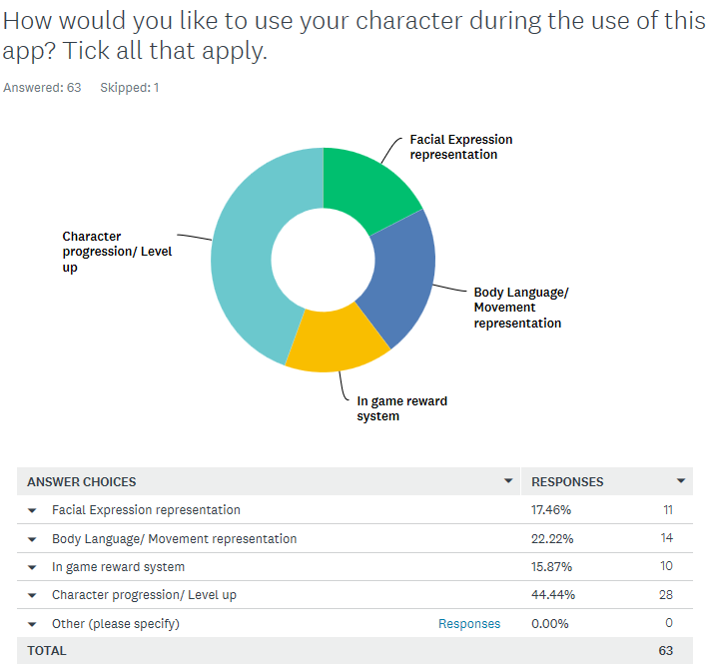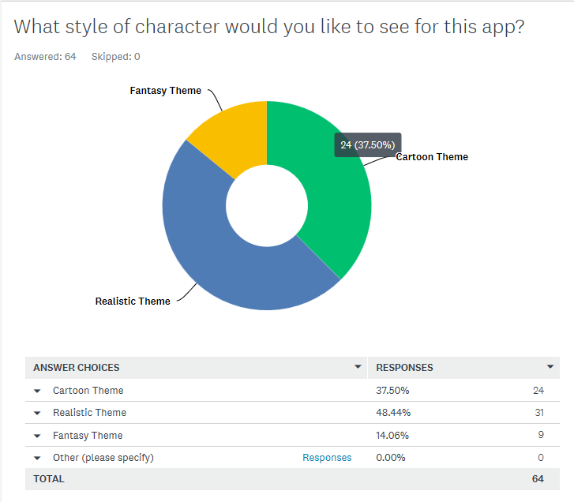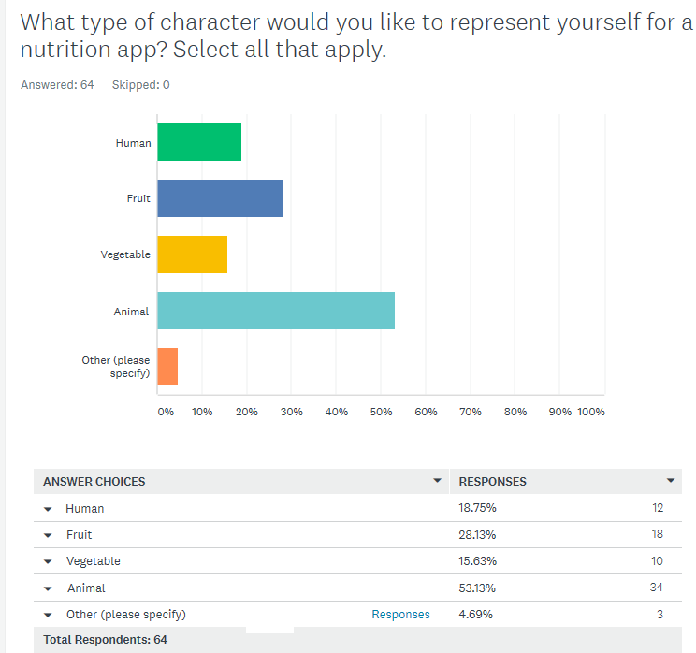

Figures 2 - 6

Based on the response to the survey our games animator and I agreed to create a game avatar with either the characteristic of an animal or fruit. It would be designed in the realistic theme, have a progression or levelling up system, and would be suitable for adults in the range of 18-34 with an audio system included.

# Designing the Avatar

Using the survey data, as a group we decided to create an avatar using a fruit base form with realistic facial features and clothing, we agreed this would be both humorous and in tune with the apps purpose, and would encourage people to keep using our app.

We did some research on potential designs using mood boards and reviewing existing avatars in animated movies. After this, we chose to create a realistic styled Avocado with human like features such as arms, face, hair and a chest with the option to add accessories to the head and face.

## Avatar Base

The software used to create the avatar was Maya 2019, as it has inbuilt tools to animate the character once completed. To create the base of the avocado a sphere was stretched upwards and outwards to create the impression of the top and bottom part of a body. The model was then cut in half and a nutty chest attached to the lower third of the body as shown in figures 6-8 (Go, A 2013)

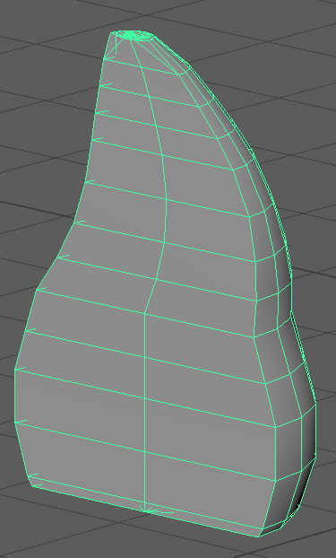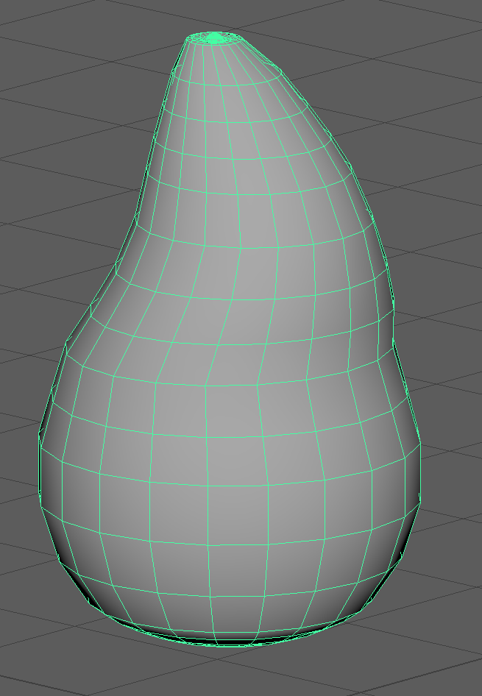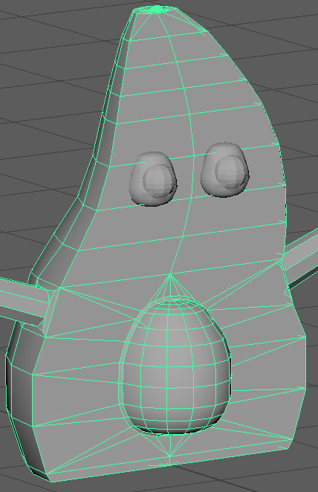

Figures 6-8

## Avatar Features

### Eyes

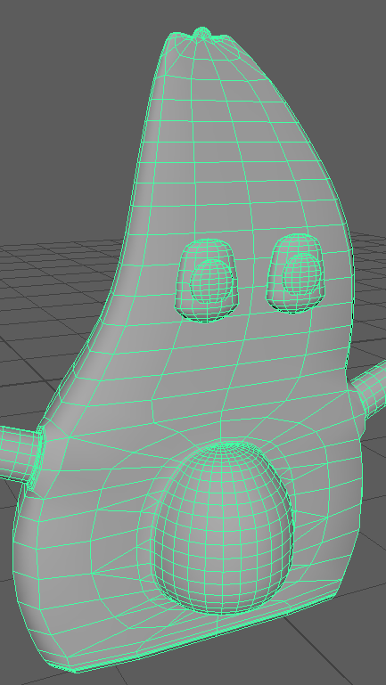After completing the body of the avatar the facial features and arms were created. To complete the eyes another sphere was created and shaped using the body nut as a guide, once it was complete it was duplicated.

A similar process was used to create the eyelids and the pupils, then the scale tool was used to reduce then in size before attaching them to the body.

To make it easier to animate them at a later date, it was decided to keep both elements of the eyes as separate objects so they could be exported together when required.

The end result is shown in figure 9

Figure 9

### Mouth & Hair

To design the hair I added a stem with a couple of leaves that could then be animated to create movement or squashed inside whilst wearing head gear.

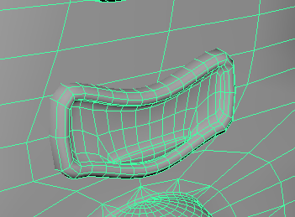I achieved this by using the extrude tool from the modelling options from the top of the model and adding several segments, so that further leaves could be added or bent, as well as making further animations easier to create. Figure 10

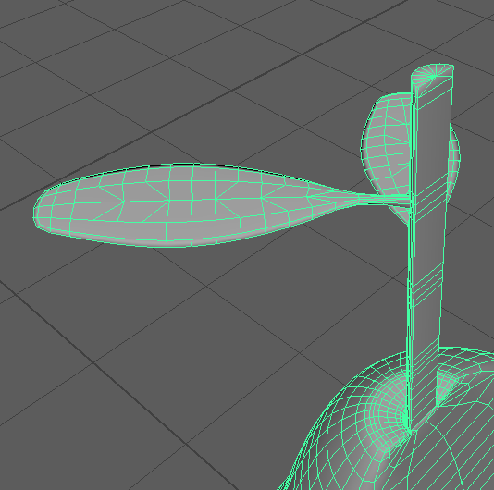The mouth was created using a box with several segments and a tongue, once that was completed the smooth and soft selection tools were used to create the curvy edges. Figure 11

Figure 11

Figure 10

### Arms & Hands:

The arms and hands were next, after some research I decided to use the same tools and methods I had used to create the facial features. I made both sides of the arms into a six sided plain face and then extruded these outwards evenly. At the end of each extruded arm I used the scale and connect tools to create the foundations of the hands.

To create the hands the extrude tool was once again used for the thumb and mitten looking hand, after which extra segments for the shoulders and elbows where created using the connect tool.

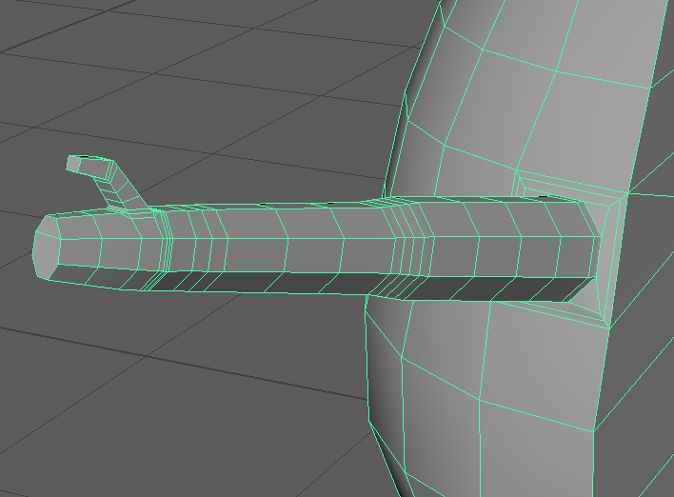This process is shown below on figures 12 & 13.

Figures 12, 13

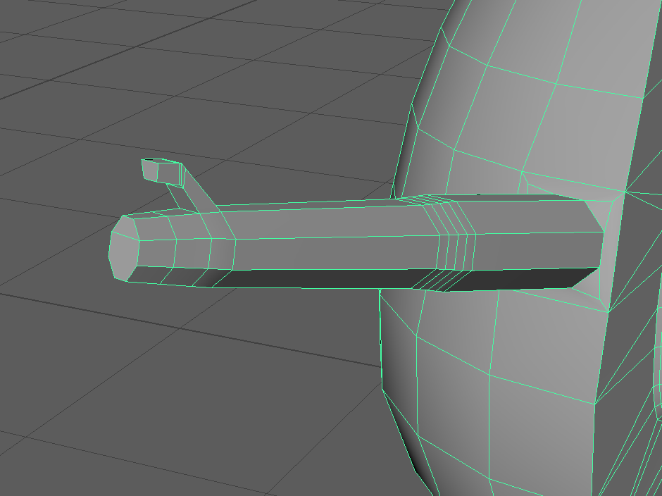

At this stage of the process the group’s animator decided that the arms would need further modification to fit in with their animation processes, which they completed themselves.

# Customisation Assets:

For my role as game designer I was tasked with creating customisation assets for the avatar. So the player could make it their own, thus bringing in more gamification and nurturing to the game. The assets I chose to create where a pair of sun glasses and a cap.

### Sunglasses:

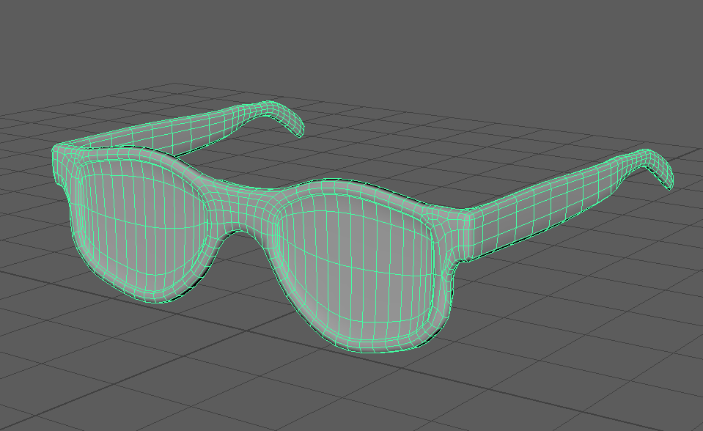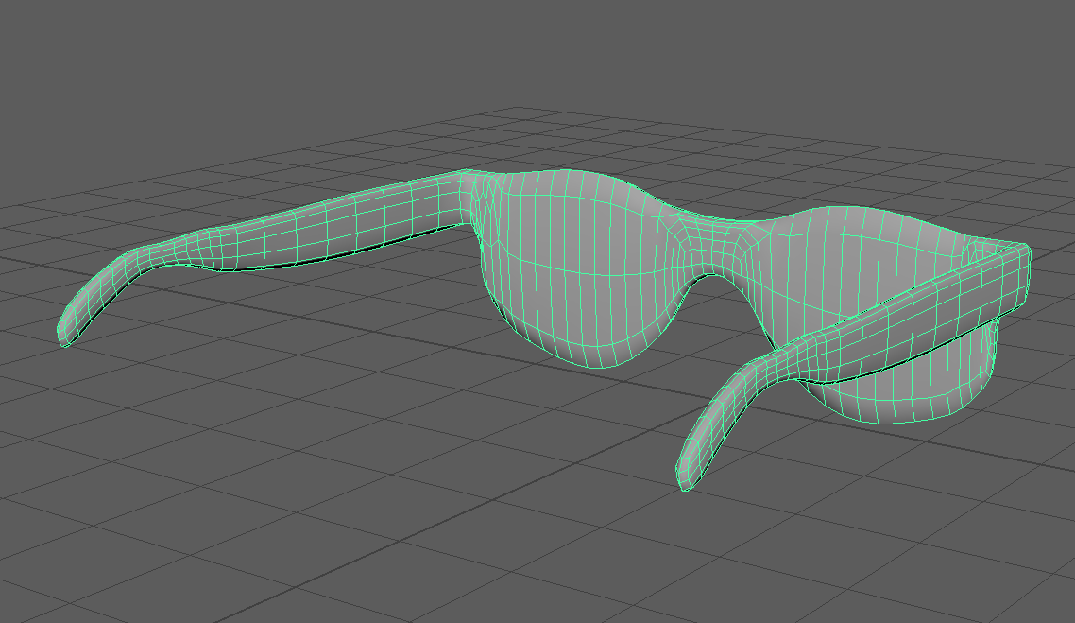The sunglasses were designed using the same methods of extruding, scale, connect, soft selection and smoothing tools. In order to improve the accuracy of each side of the model and to ensure they were symmetric, I used the snap to vertex tool and the “local translate Z” option within the extruding tool. This ensured the result was symmetric, after which it was finished off using the smoothing tool. Results are shown on figures 14 & 15 below (Pretavoir 2020).

Figures 14, 15

### Cap / Snapback:

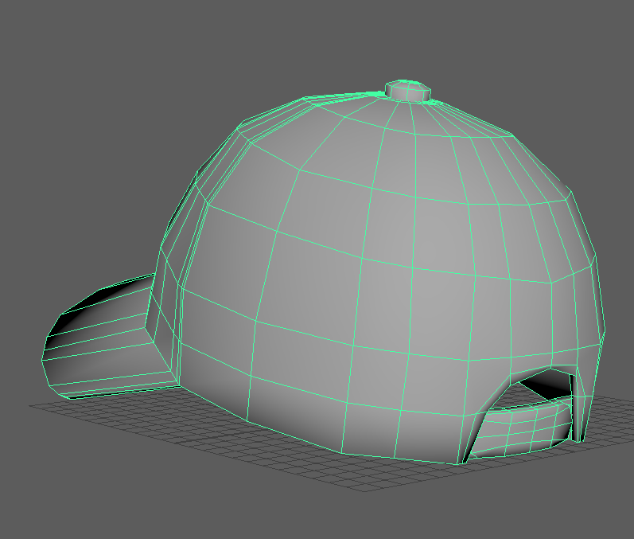The cap or snapback was designed using the same methods of extruding, scale, connect, soft selection and smoothing tools, however in order to add the extra details on the back of the cap such as the hole and strap, I used the multi cut tool which allowed me to add free handed segments to the model. I used this tool to add the top rounded area of the cap as well as the hole at the back after deleting the faces and using the bridge tool to bridge the faces on the outer parts of the hole. The results are shown on figures 16 & 17 (KG, A 2020).

Figures 16, 17

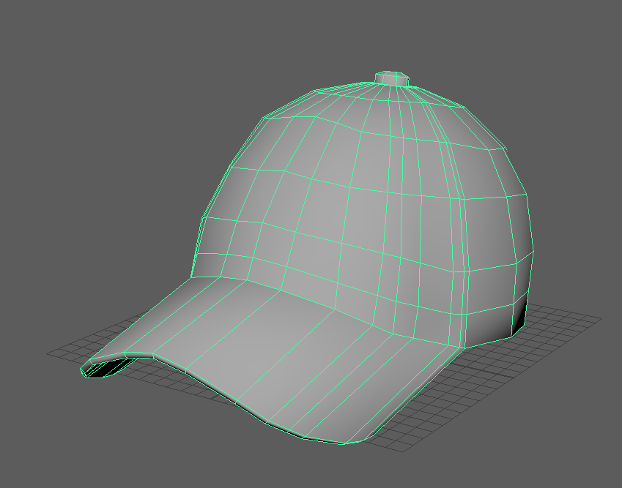

# Challenges & What I’ve learned:

### Modelling Software:

One of my main challenges in this module was the requirement to learn a new 3D modelling application, that being Autodesk Maya 2019, which whilst similar to Autodesk 3DS Max 2018, that I am proficient with, uses different methods to access the tools, which initially slowed me down making it more difficult to complete tasks efficiently and on time.

Thus I spent the first month of the project learning how to use this software with the help of the group’s animator, which will also be very useful for my personal projects.

### Organic Modelling:

My second main challenge in this module was the need to model living organic objects, as this is something I did not have a lot of experience doing. Nevertheless I trusted in my ability and willingness to learn new ways of modelling, and whilst it sometimes took longer than I would have liked, and caused a few holdups along the way, the final product pleased everyone which made me very happy with my final creation.

# Conclusion:

My role and responsibility in this project was to design and model the player’s avatar as well as creating assets for the player to customise their character with. The group came up with this idea due to the failed attempts at avatar implementation in other apps, software programmes and games. I was also responsible for ensuring all the assets are ‘legal’ meaning they can be seamlessly imported into 3D engines, which in our case was Unity.

As game designer, the role I had in this project was different from what I’m used to doing, and required me to address skills which I have not used in years, but I was prepared to take on the challenge and learn in the process.

Thus the designs I was tasked with creating and the implementation of this project, presented me with a big opportunity to build on my current skill set in modelling which I thoroughly enjoyed.

# References

Compsoft.co.uk. (2020). *9 Worst Apps Ever Developed*. Available at: <https://www.compsoft.co.uk/news/9-worst-apps-ever-developed> [Accessed 20 Oct. 2019].

Go, A. (2013). *avocado time lapse / 3d modeling*. YouTube. Available at: <https://www.youtube.com/watch?v=MZlz6RmVG84&t=63s> [Accessed 1 Nov. 2019].

KG, A. (2020). *Liberty Baseball Cap - 8,95 £*.Hatshopping Shop. Available at: <https://hatshopping.co.uk/Liberty-Baseball-Cap.html> [Accessed 5 Dec. 2019].

Pretavoir.co.uk. (2020). *Cutler and Gross 1339 01 Black Grey Sunglasses | Pretavoir*. Available at: <https://www.pretavoir.co.uk/cutler-and-gross-1339-01-black.html?cs=yes> [Accessed 25 Nov. 2019].

UX Agency, S. (2018). *Apple Health nutrition calculator mobile app AR / AI concept*. YouTube. Available at: <https://www.youtube.com/watch?v=hyrJt3WMy64> [Accessed 15 Dec. 2019].